**Phase-End Project**

**Customer Support Logger**

**Aim:**

To develop a web application helps them to record their customer support executive’s daily contribution toward customer support activities.

**GitHub Link:**

[**https://github.com/Sukirthalakshmanan1/customer**](https://github.com/Sukirthalakshmanan1/customer)

**Procedure:**

* Create an ASP.NET MVC application and enable the docker support.
* Docker file will be created .
* Create a SQL database in Azure named customer.
* Create an ado.model in the model and used DB First approach and select the connections and necessary authentications.
* select the tables(UserInfo and custinfo) and click finish.
* Create a Library DAL and write Test in it.
* In the Home controller Login and complaint page code is written.
* Create views Index and Dashboard and run in IIS
* Create a new Git Repository and push the code to GitHub
* Open Jenkins and create new item -> free style project and click ok.
* Go to configure and go to Github repository and paste the Github link
* And write your credentials
* Save and build
* After successful build go to configure and and add visual studio
* And copy the msbuild path and paste and save
* Build now
* On successful build Console Output is shown.
* Go to configure and build trigger->build periodically
* Set the time to build automatically and click save.
* Build happens automatically.

**Docker commands:**

* docker build –t dockerid/loginpage:latest .
* docker run -p 9091:80 dockerhubid/projectname –p

**Output:**

**Docker Desktop output after creating MVC application with docker support:**

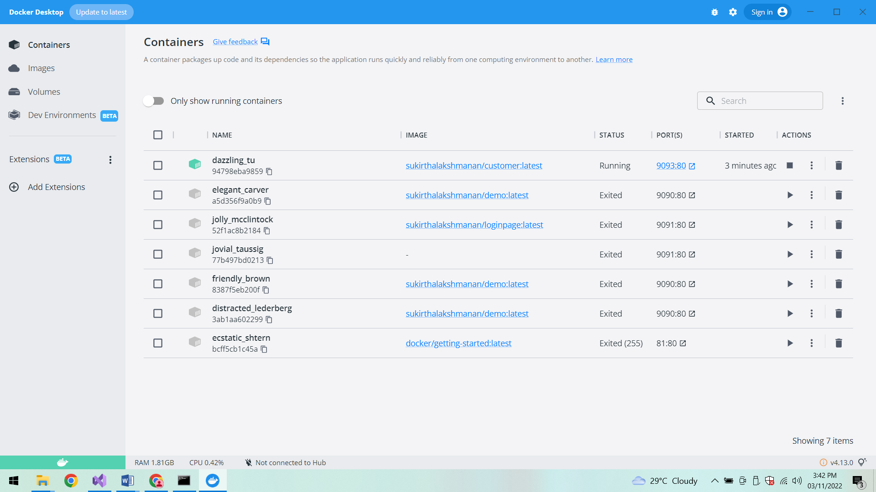

**After creating SQLServer database on Azure**

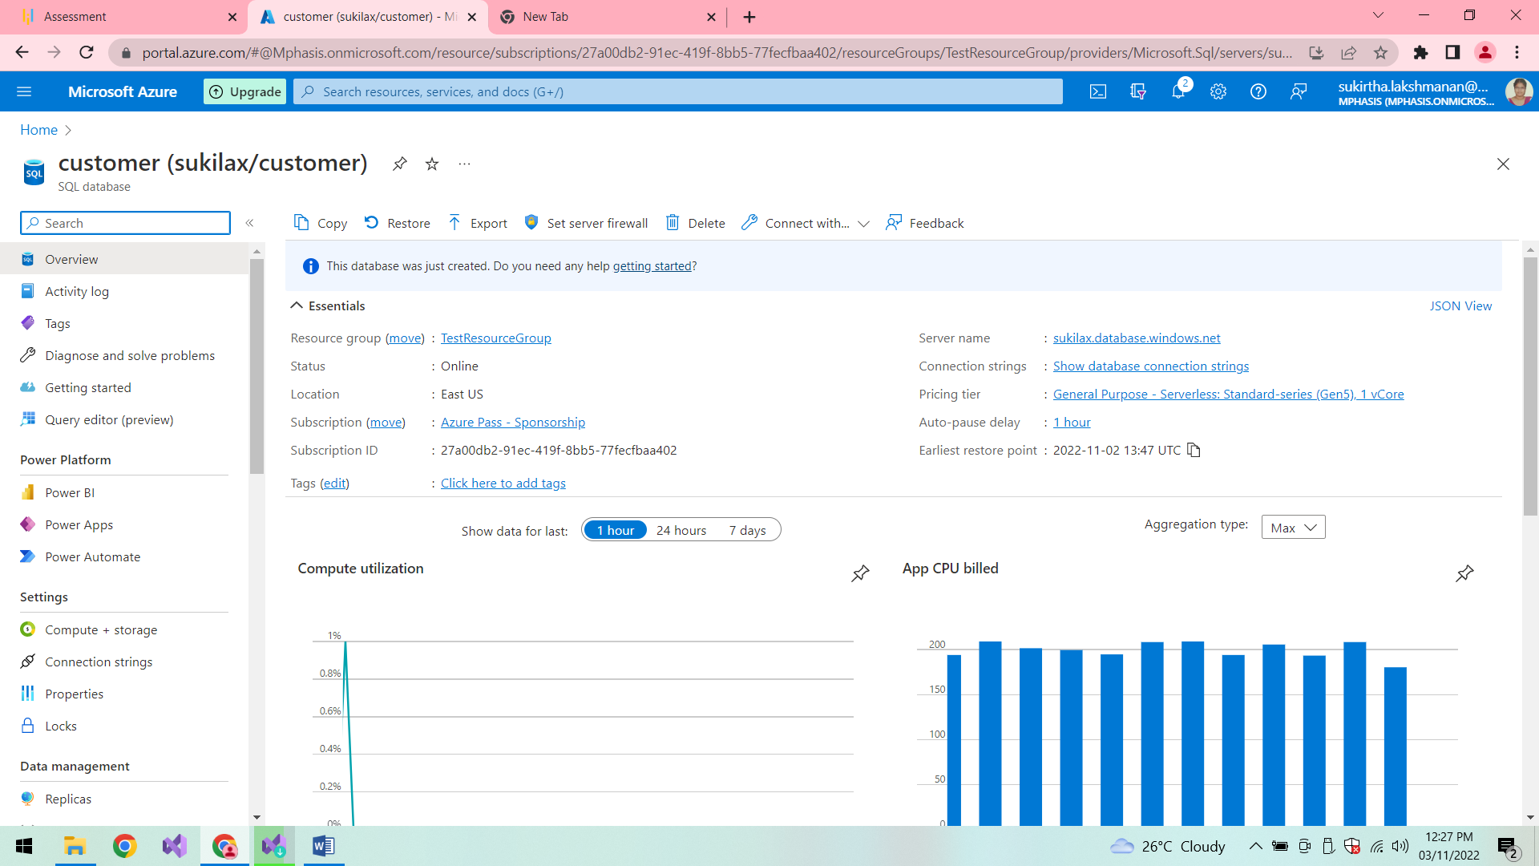

**Azure database in Local machine:**

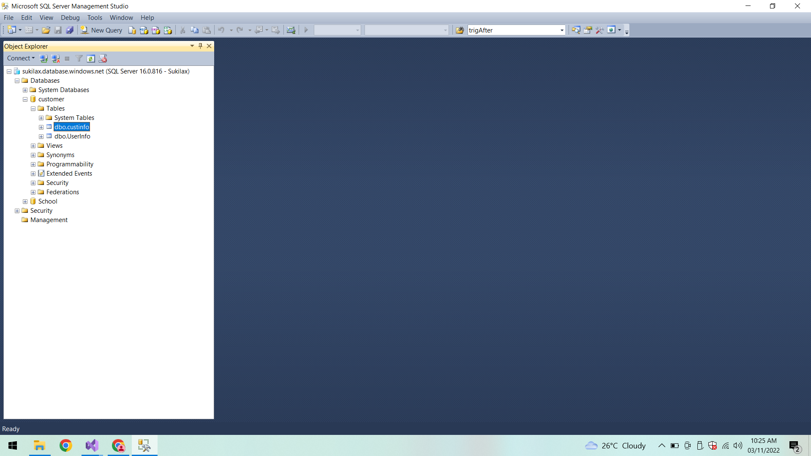

**UserInfo:**

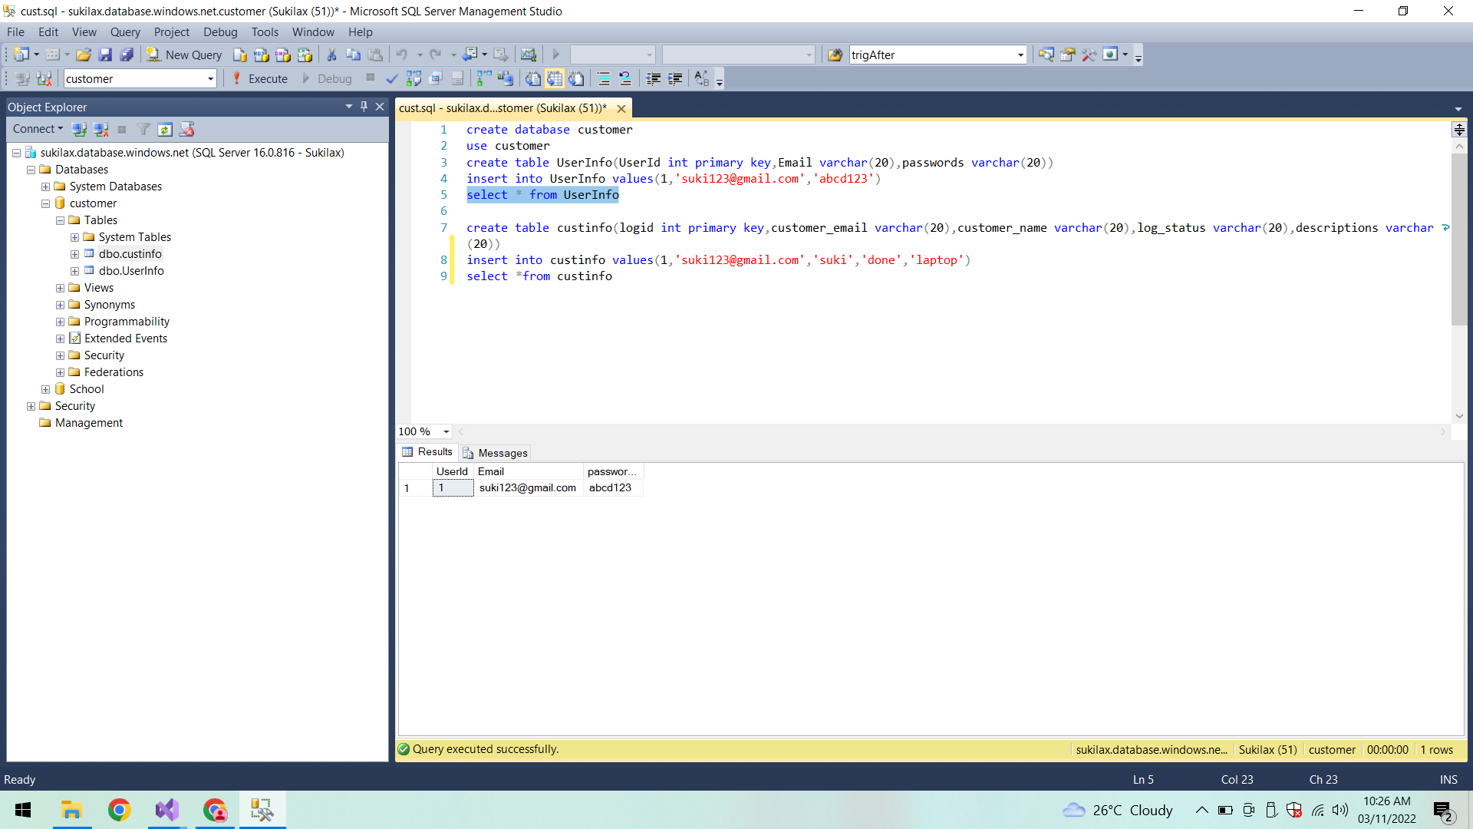

**Custinfo:**

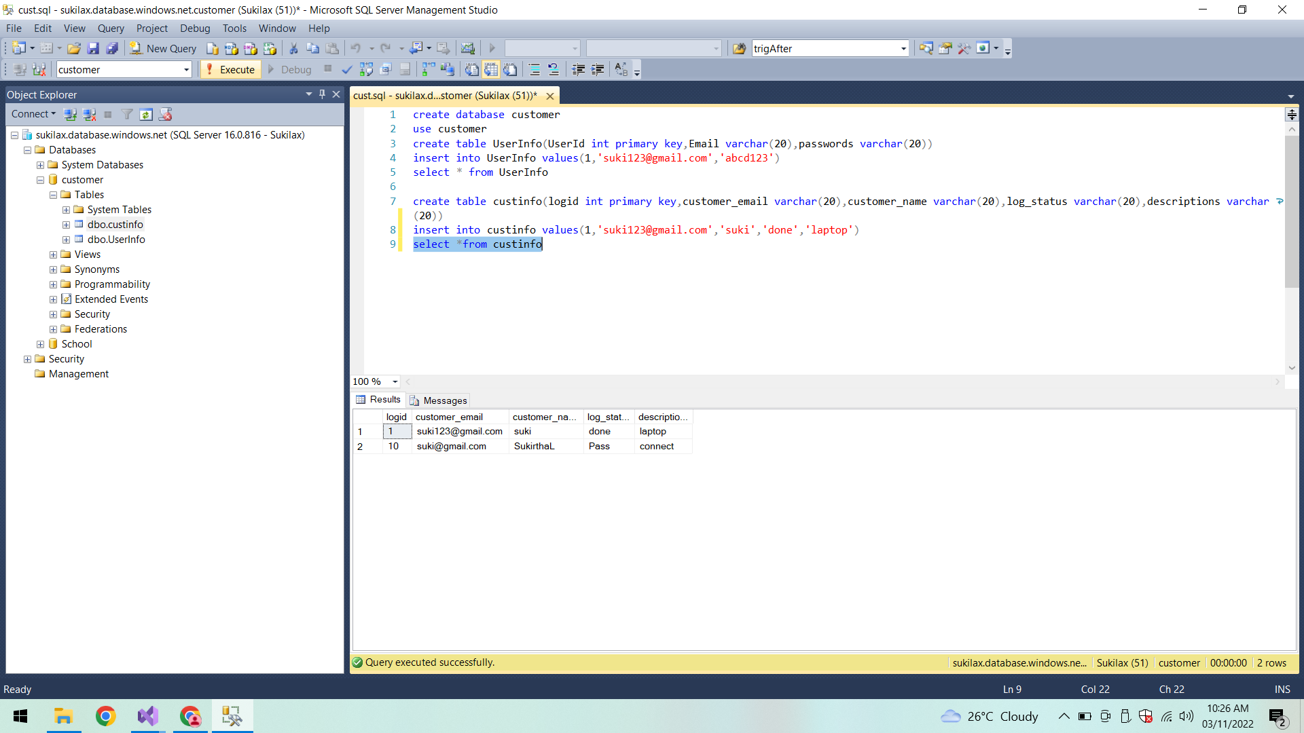

**Testing All Test cases:**

**UserInfo and CustInfo Test cases:**

All test cases passed here.

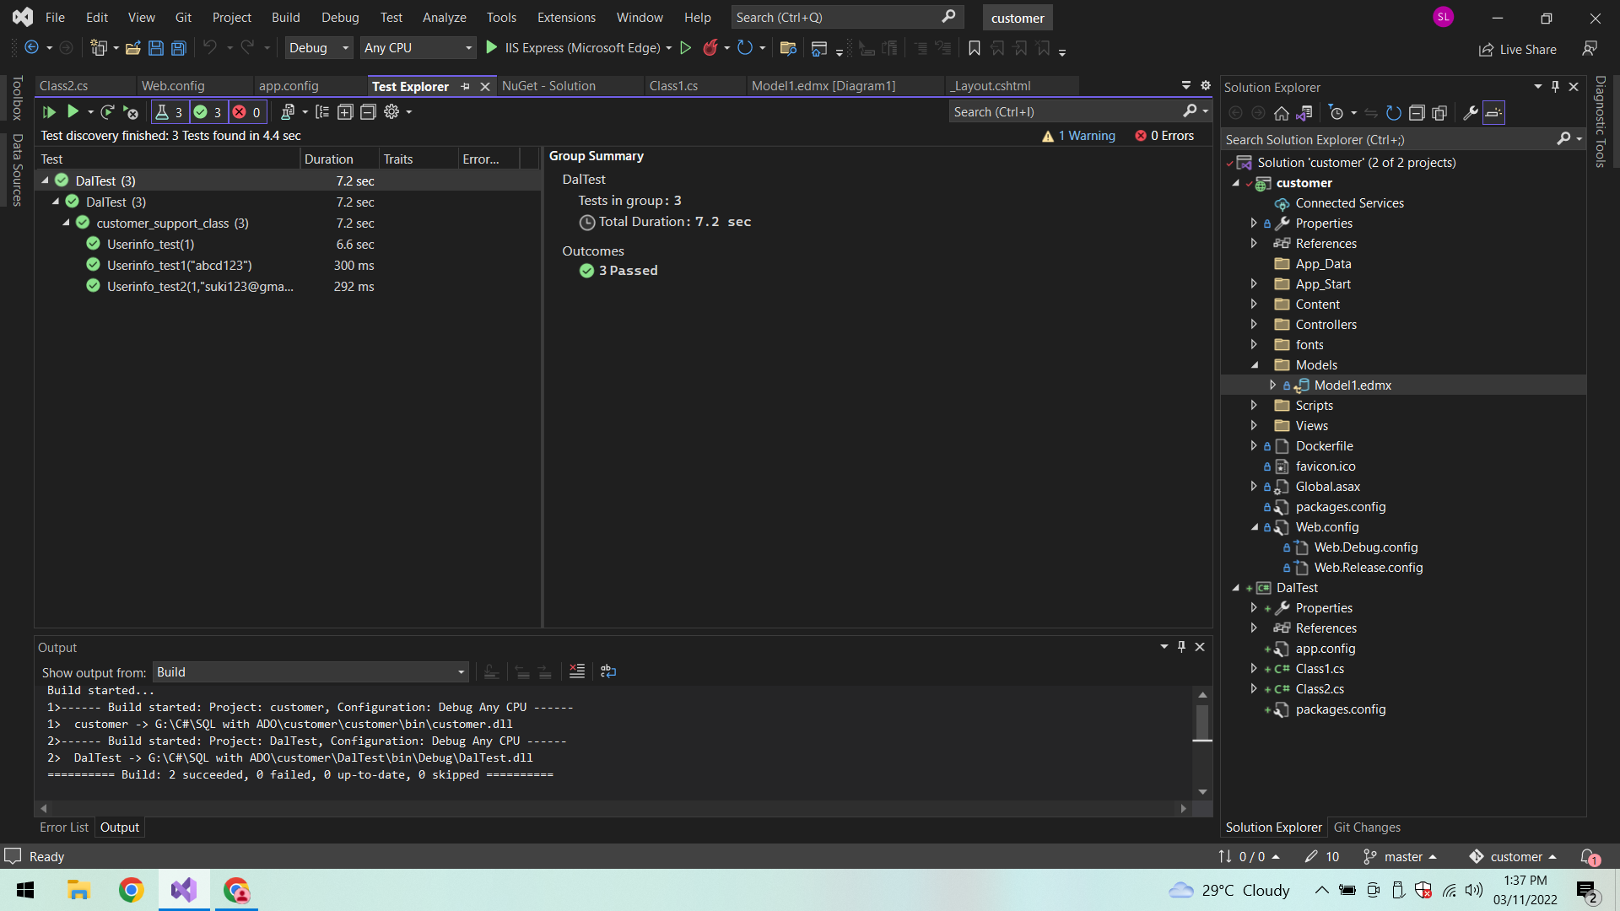

**UserInfo_test(1):**

In CustInfo On Testing the Log id:

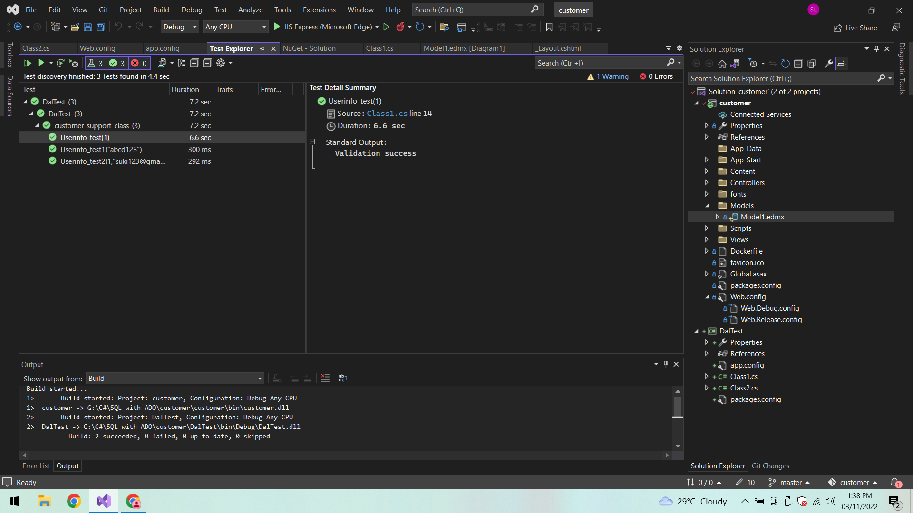

**Checking Password in login page:**

**Test case Passed:**

Giving the same password as in Azure database so that Testcase passed.

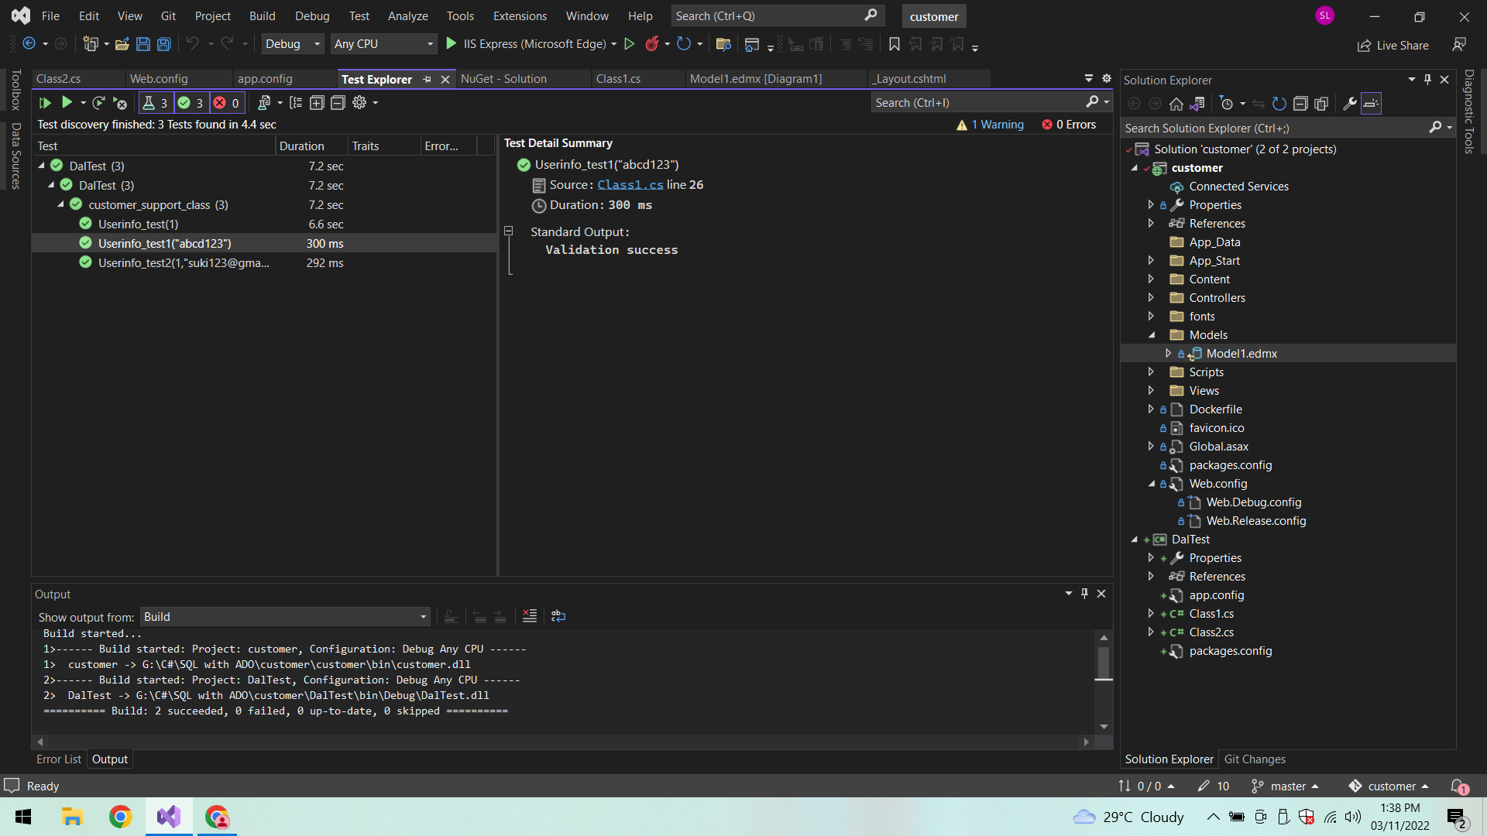

**Test case Failed:**

**Incorrect password:**

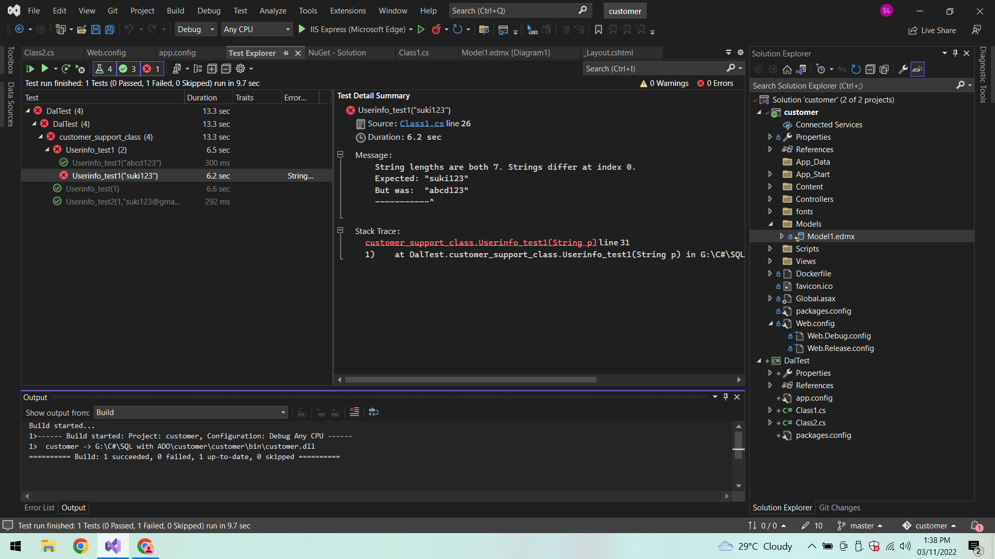

**Checking Email and UserId:**

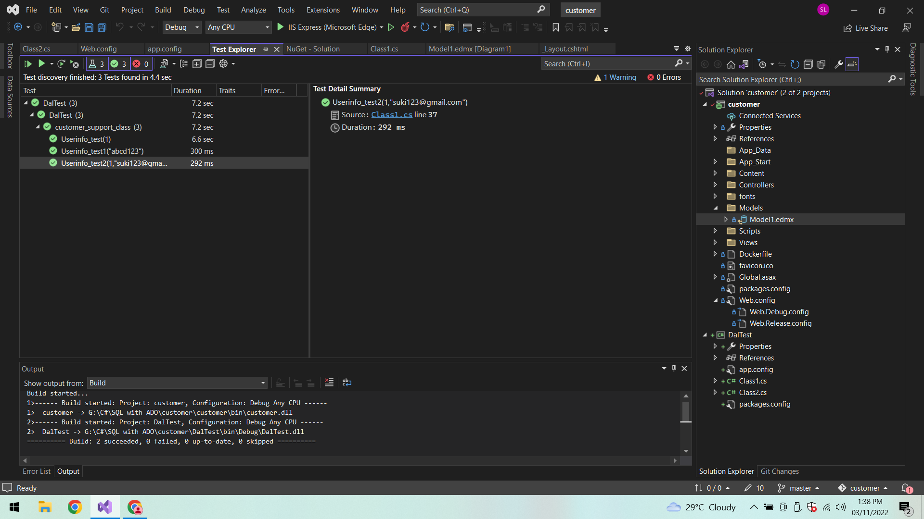

**After executing MVC application**

**a. Customer executive login page:**

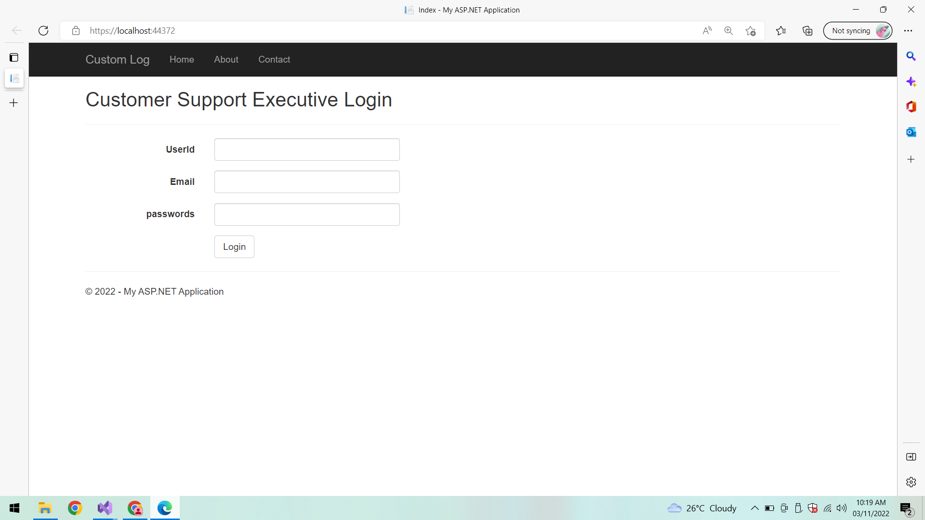

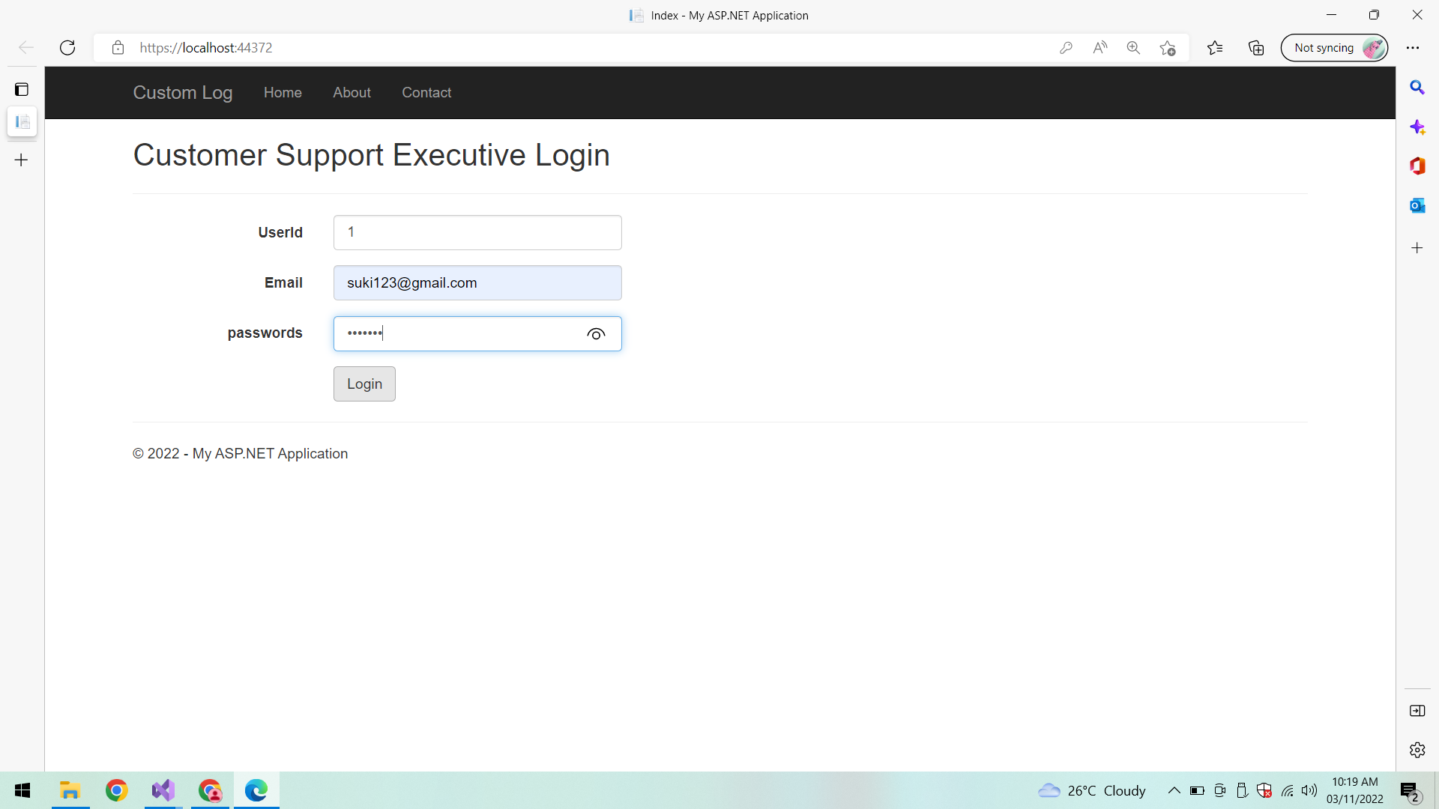

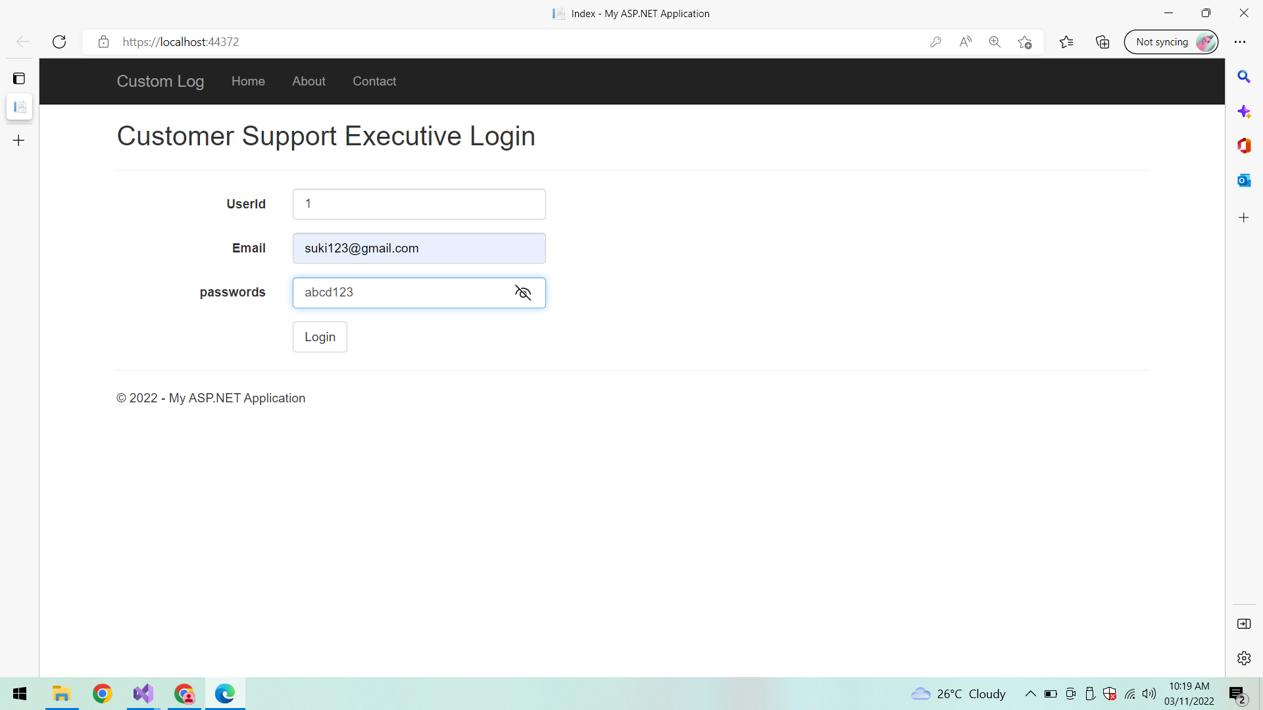

**Login:**

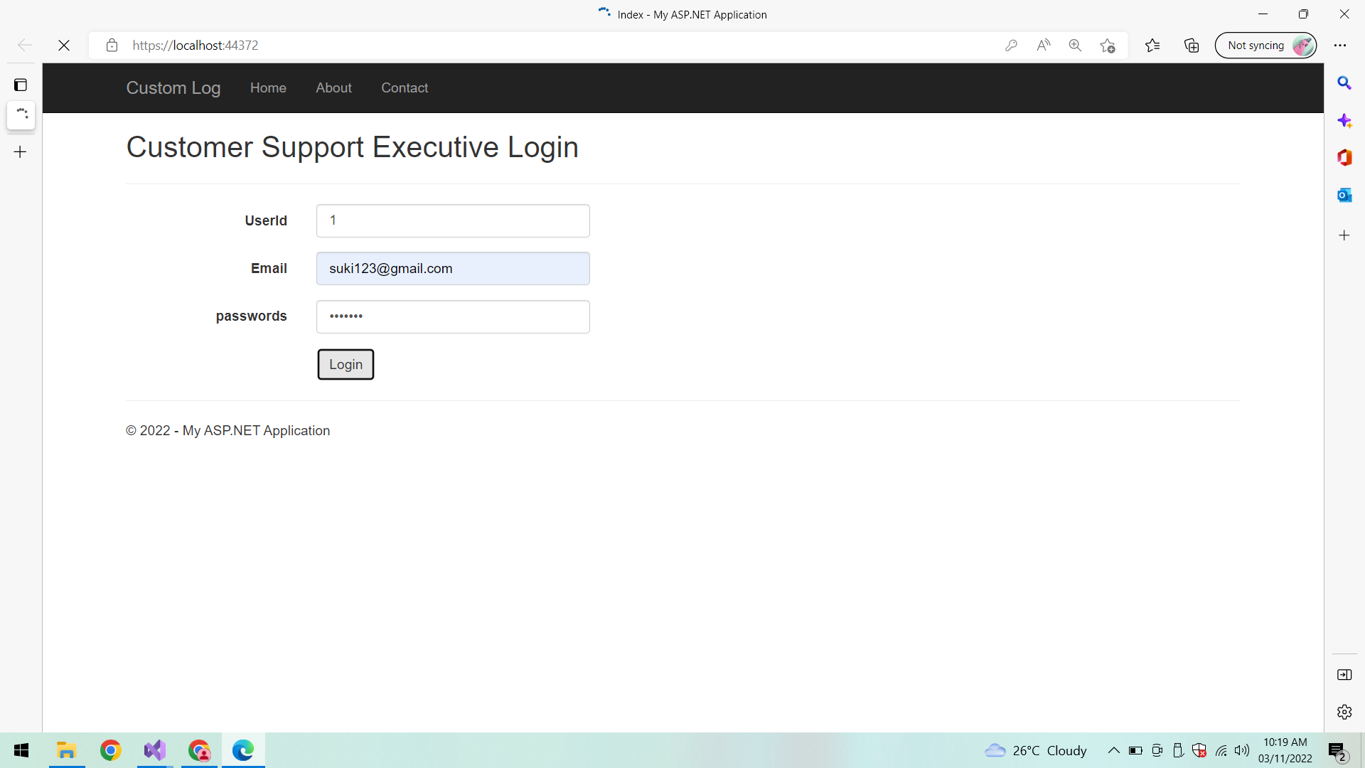

**Dashboard:**

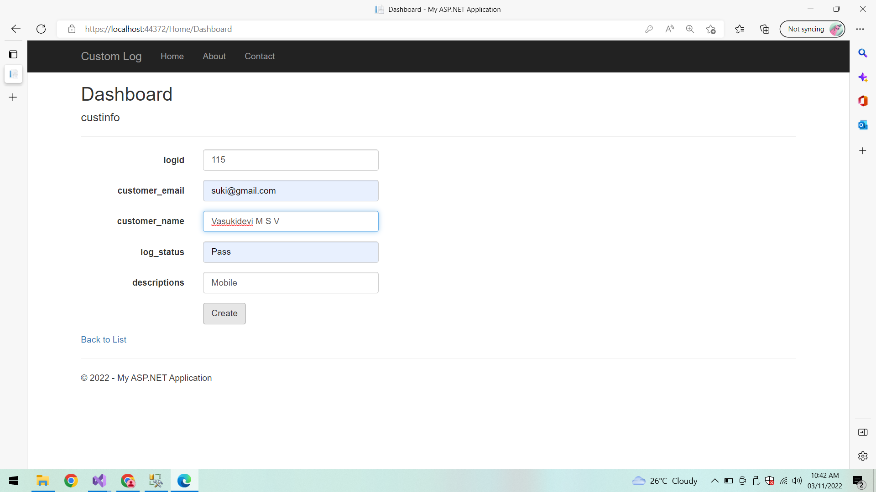

**After Registering complaint successfully Redirects to Login page:**

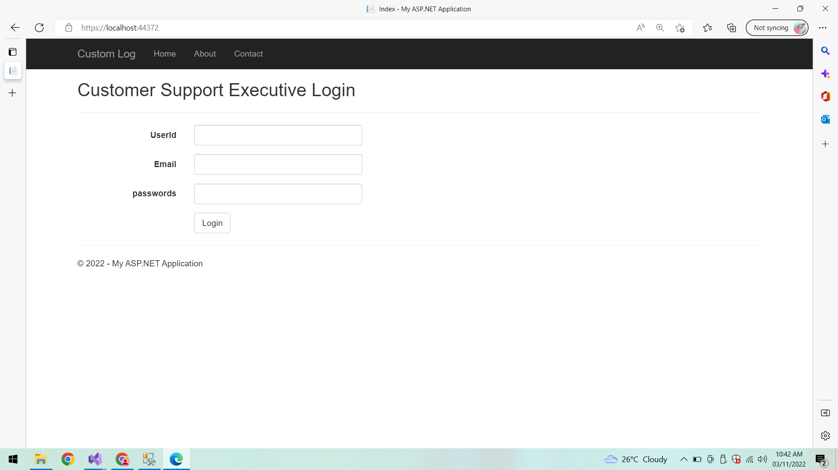

**Verifying results into the database by connecting to SQL Server Management Studio (SSMS):**

**UserInfo:**

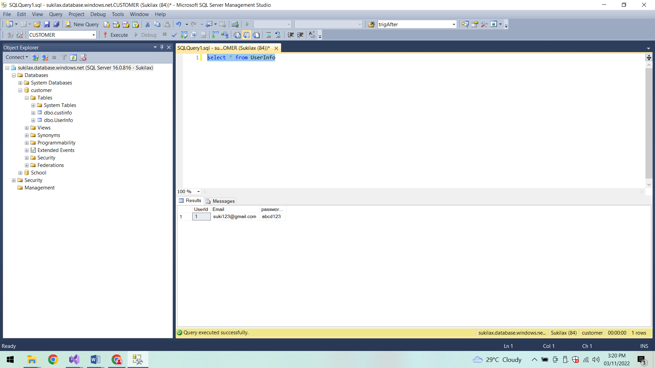

**Customer Support Info:**

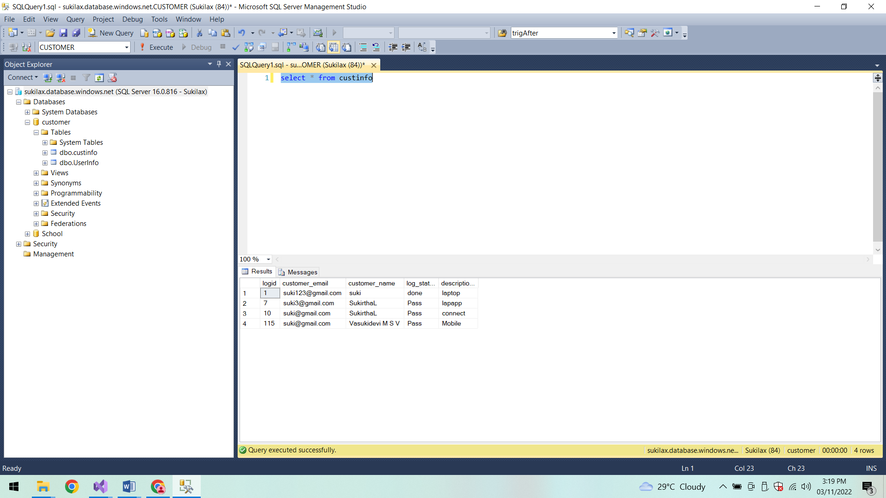

**Model:**

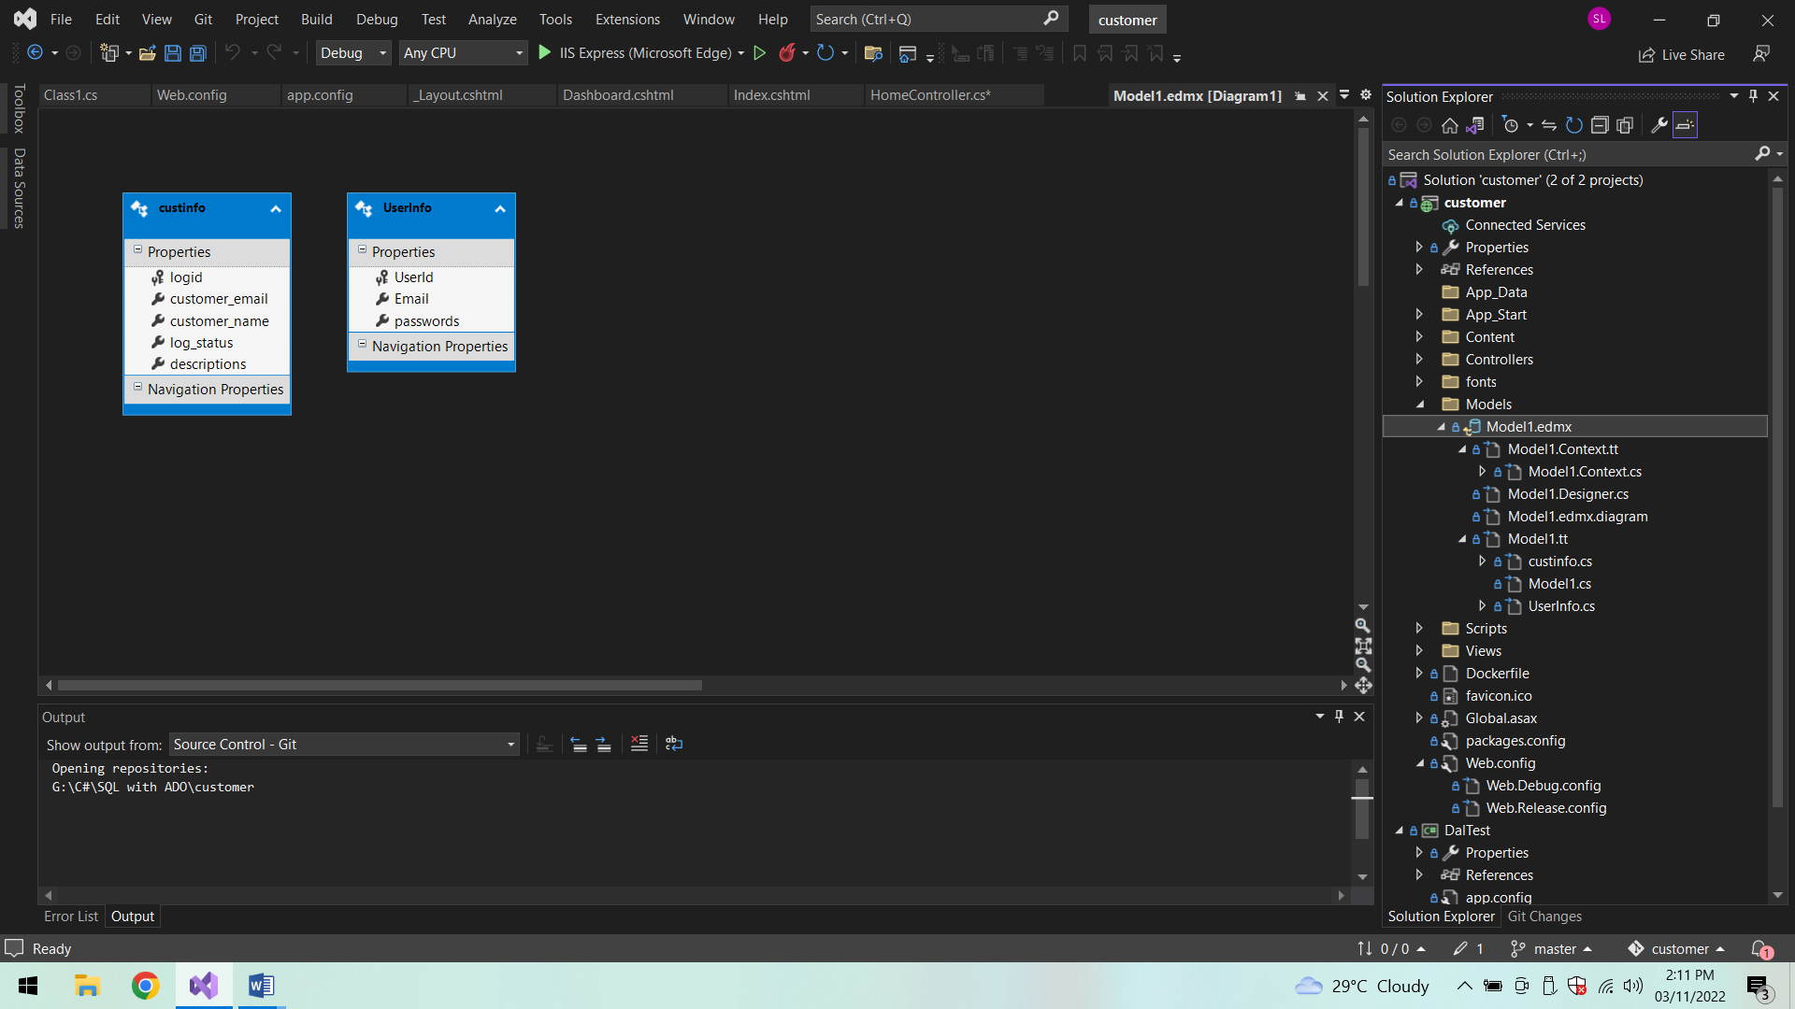

**Jenkins:**

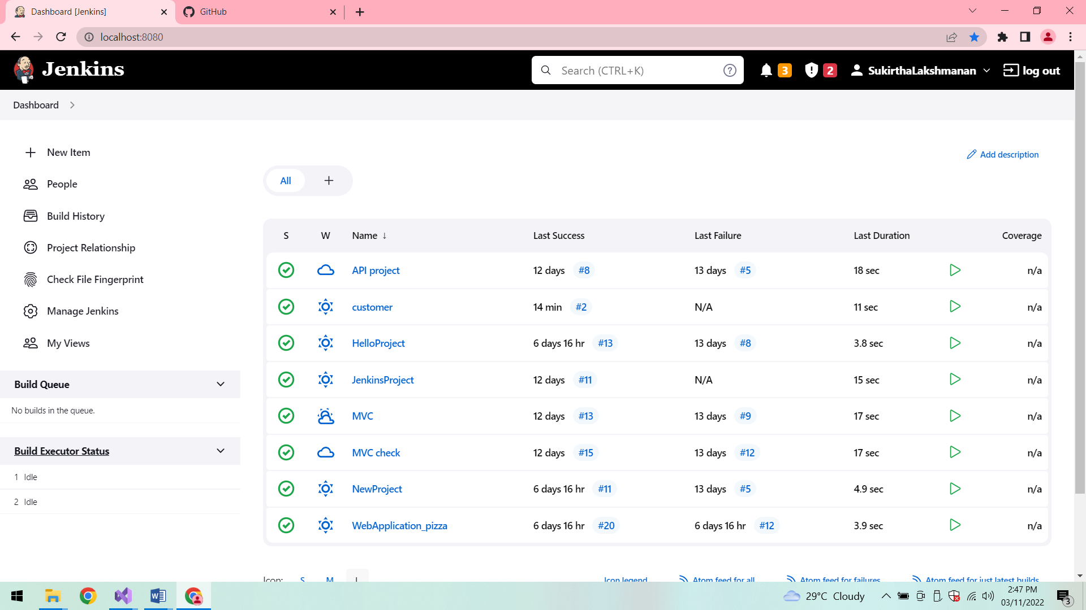

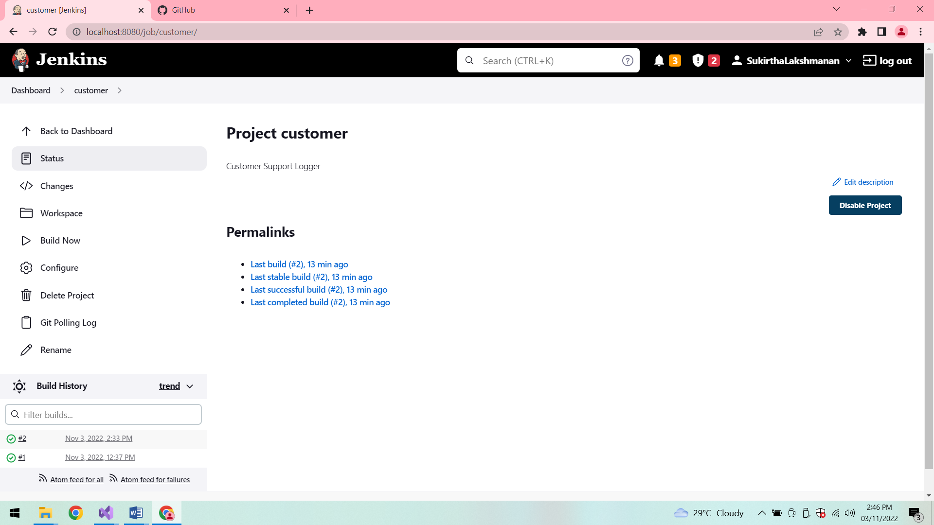

**Console Output:**

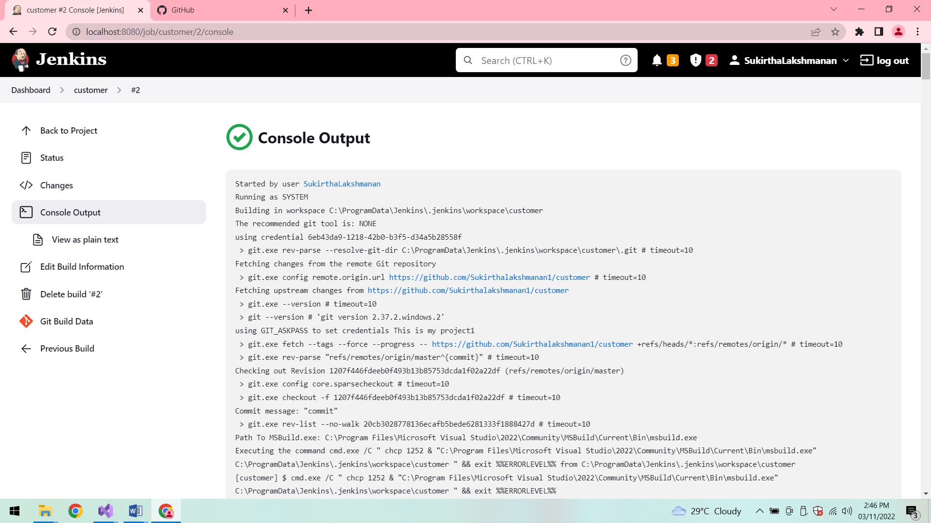

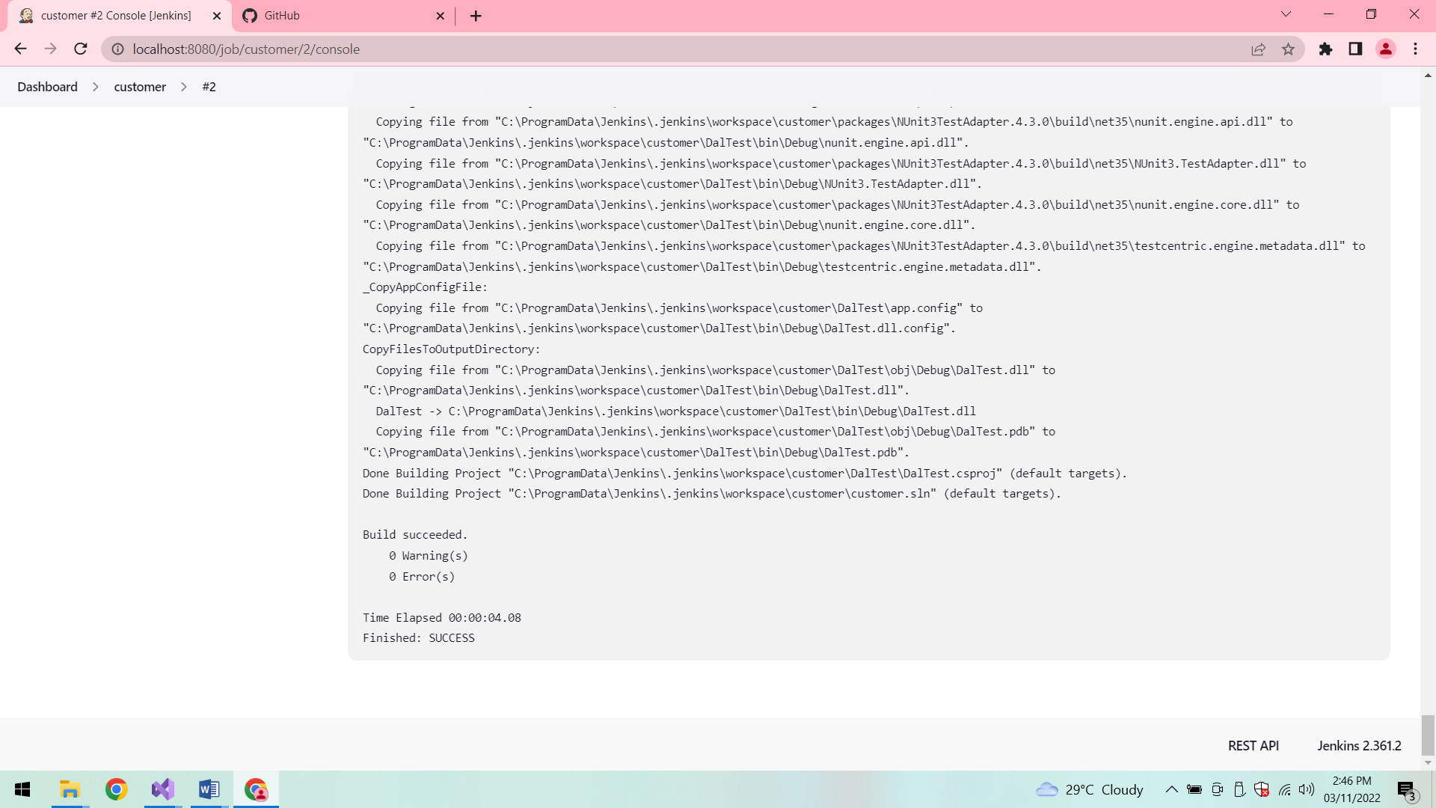

**Build 2:**

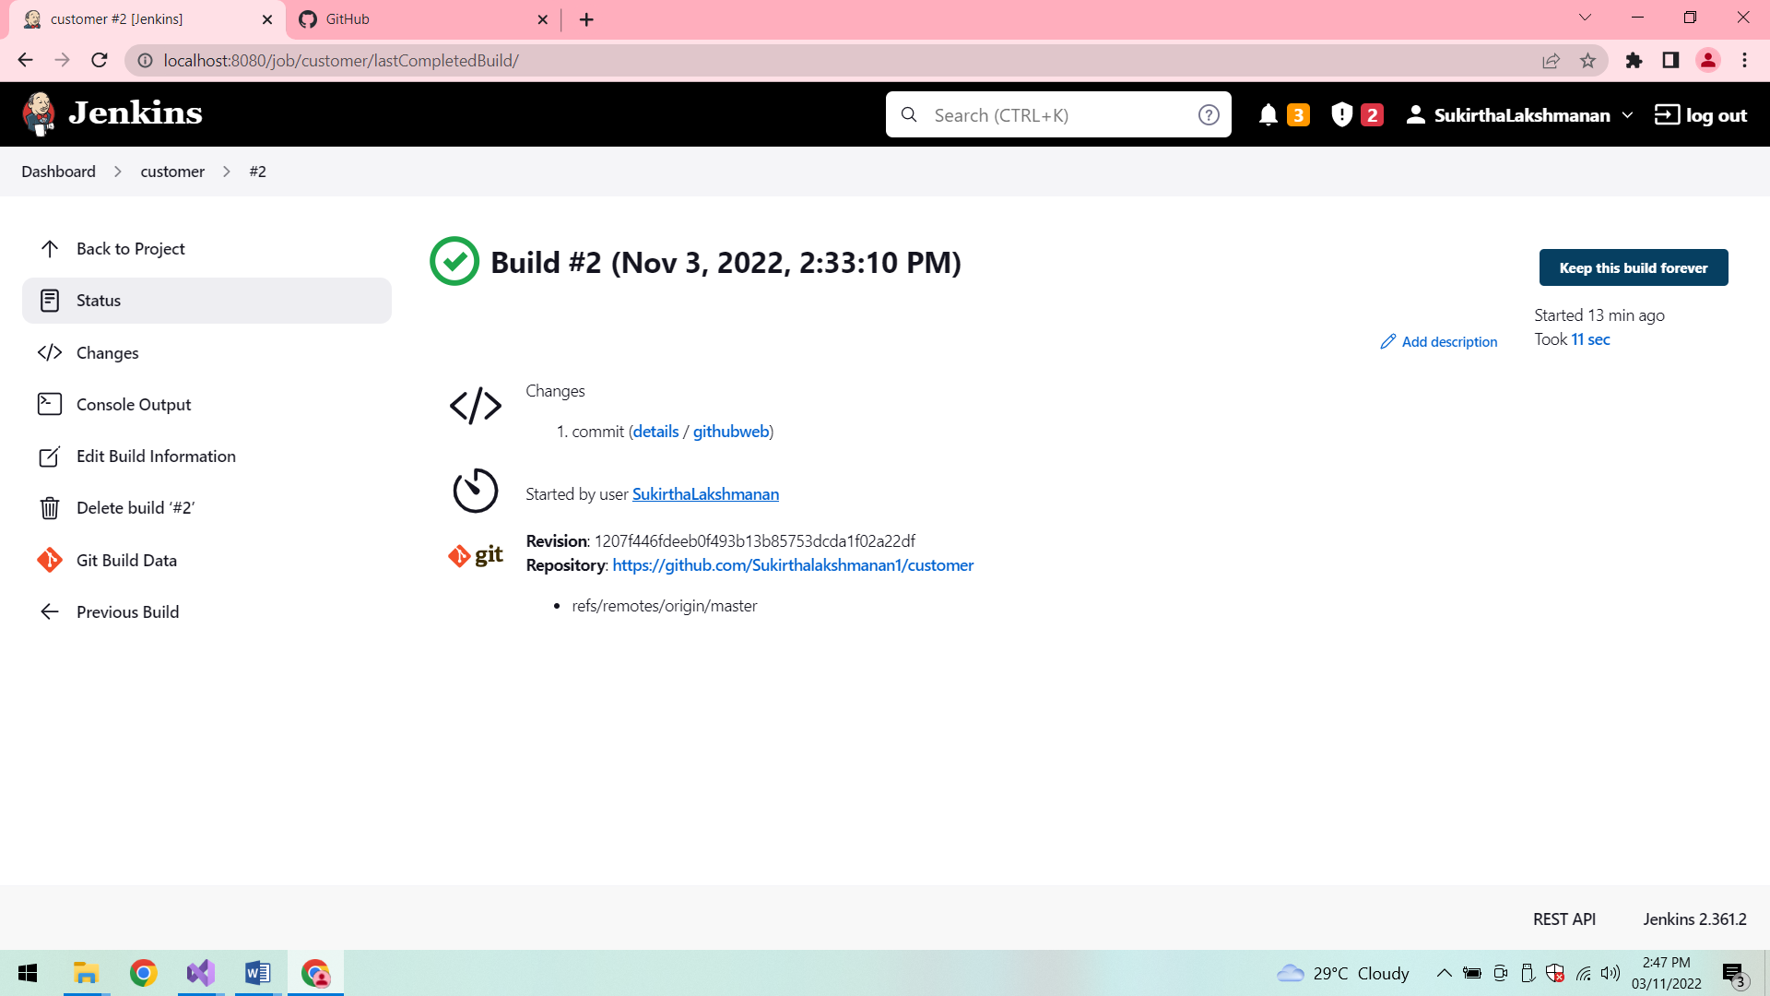

**Poll SCM:**

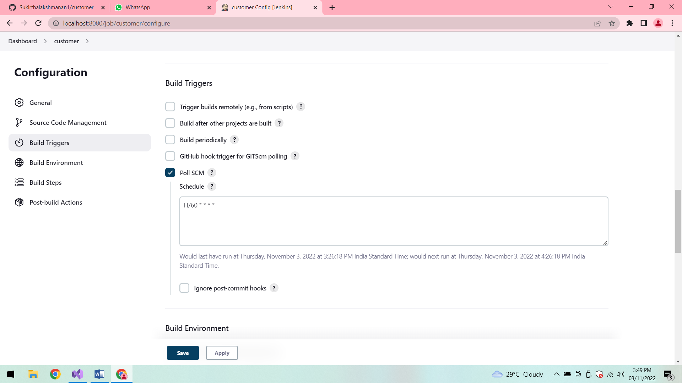

**Build 3:**

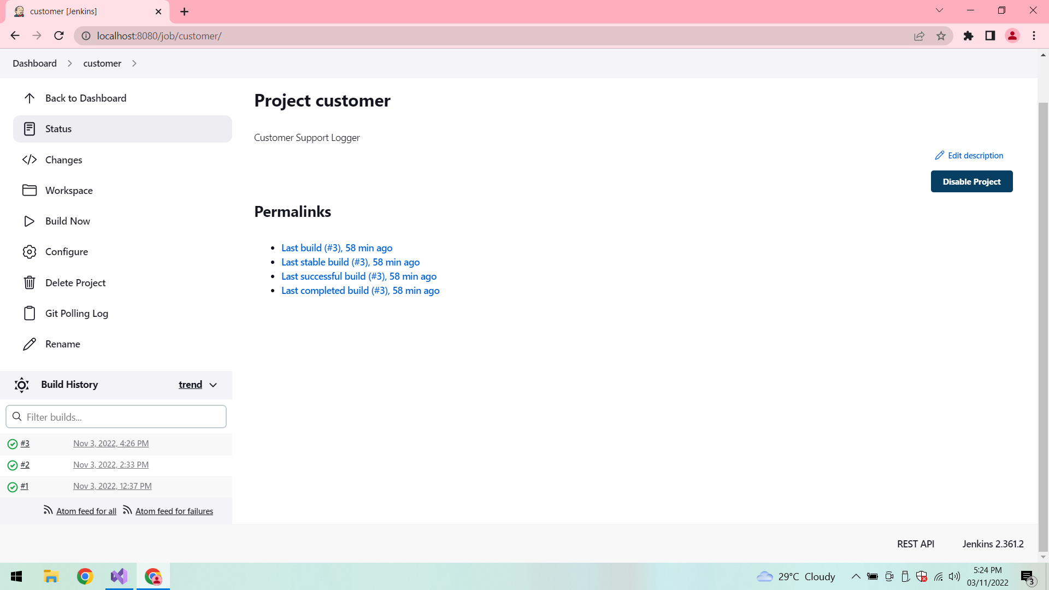

**Conclusion:**

Thus the application is developed successfully.